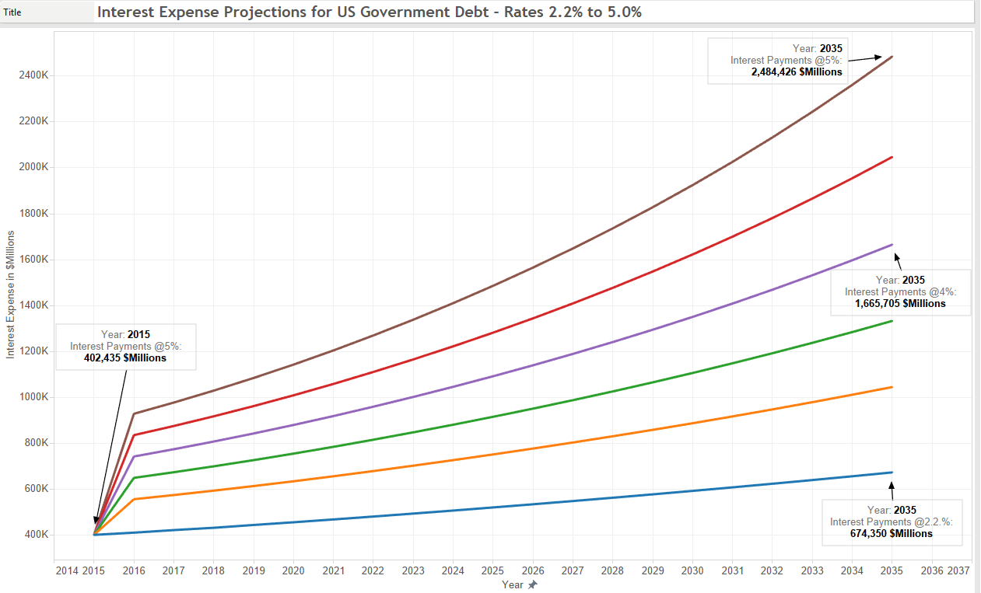

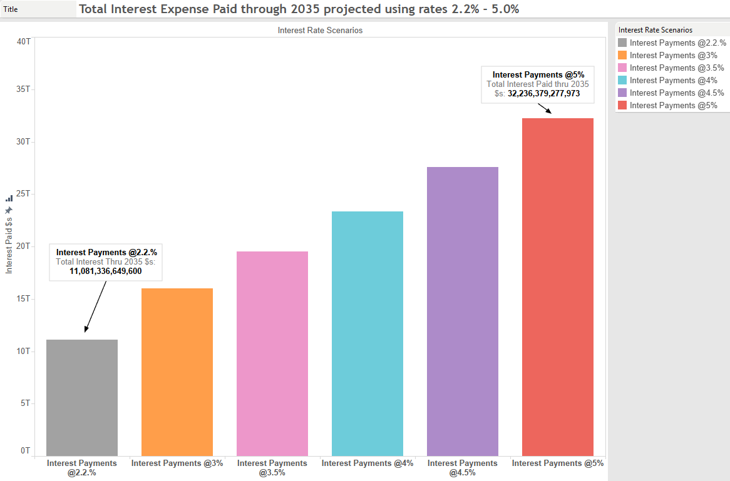

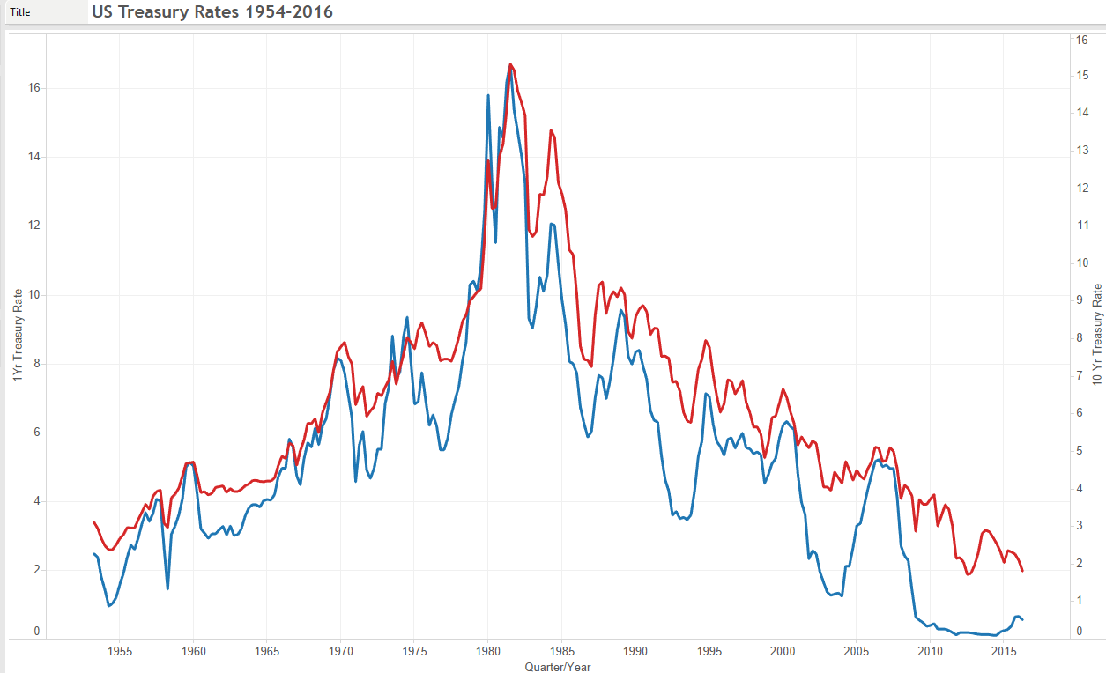

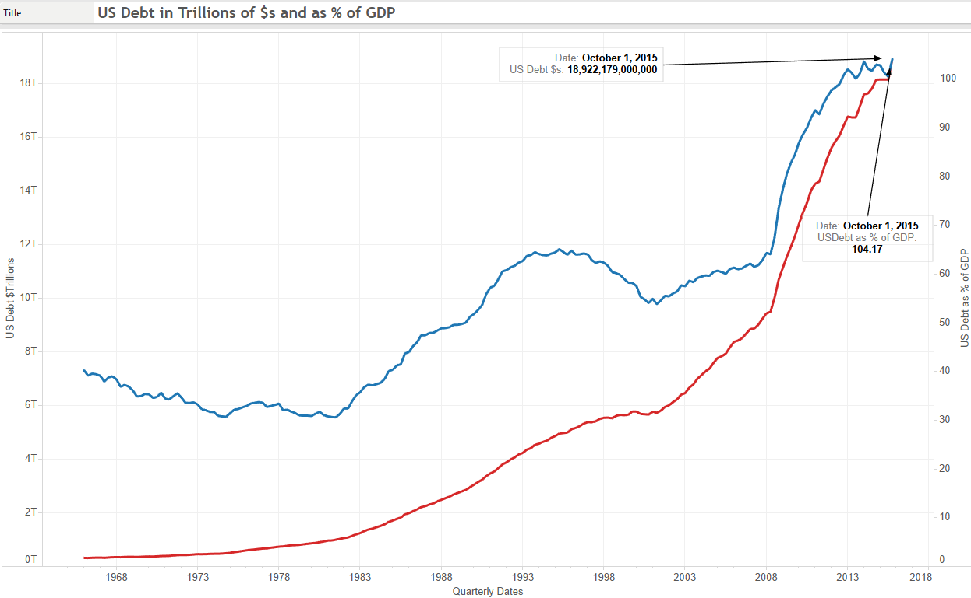

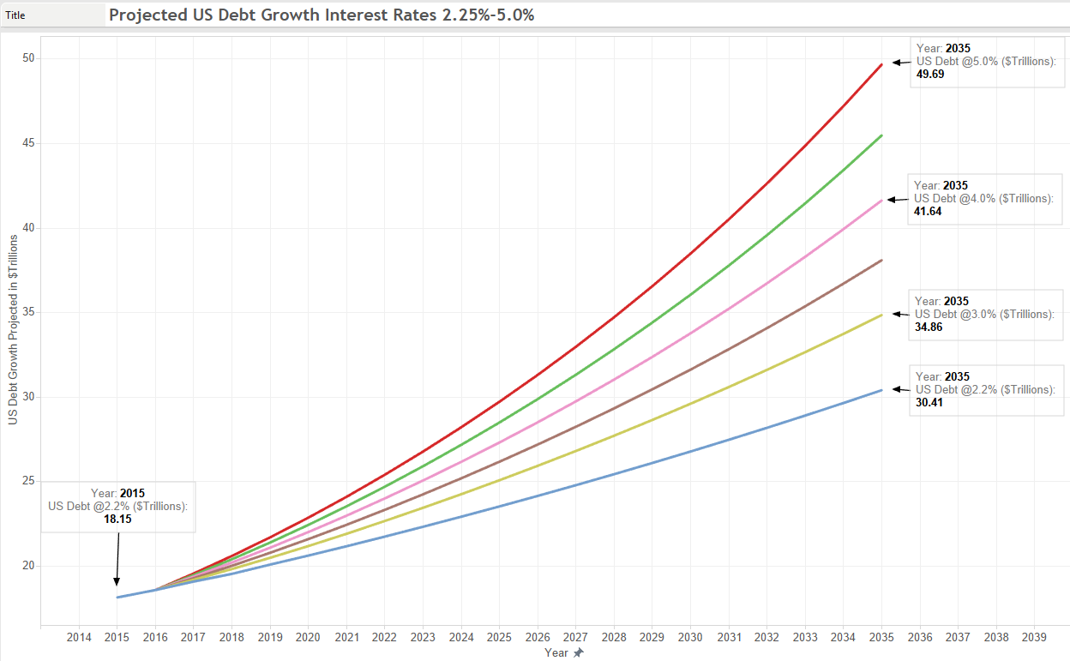

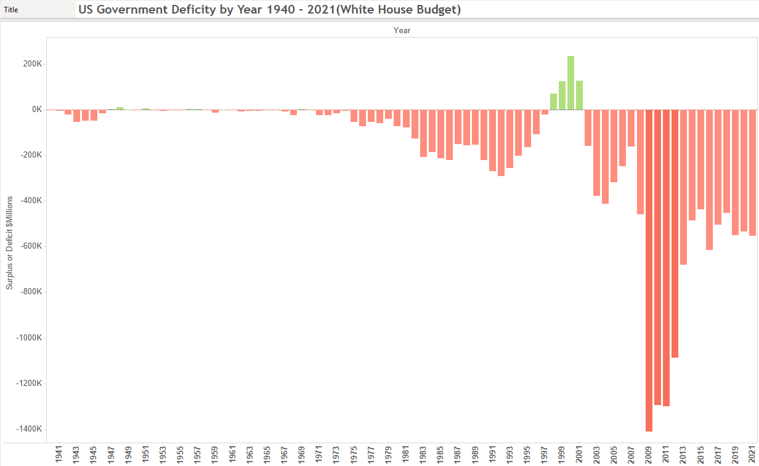

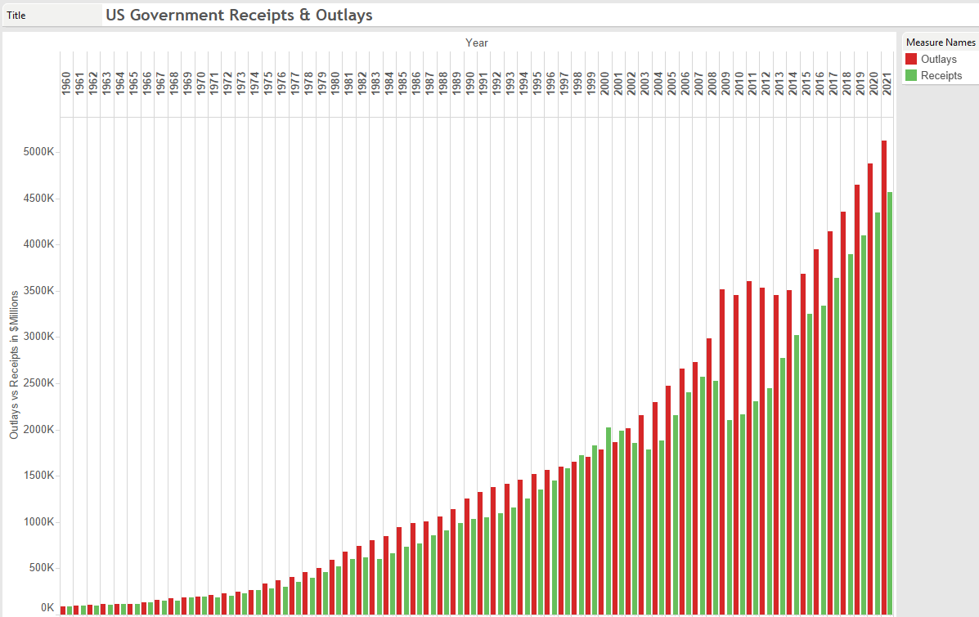

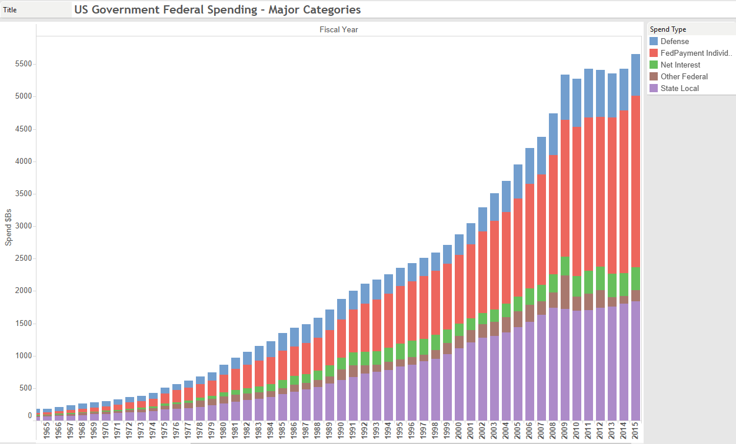

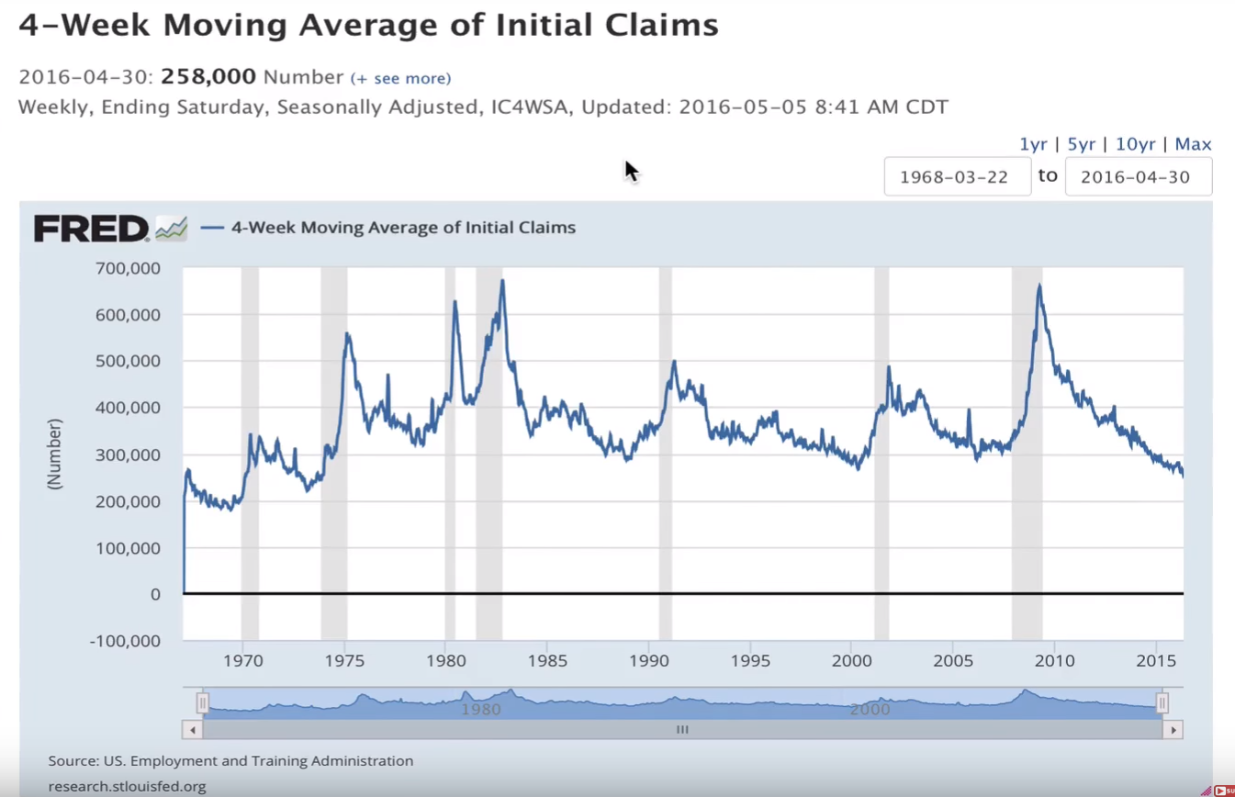

Don’t think we can reduce Fed Payments to Individuals anytime soon. Unemployment numbers are known to be unreliable and continually adjusted to reflect politically acceptable numbers and with unemployment looking so good in 2016, we will see another spike up in next recession and there won’t be political capital to reduce Govt benefits already promised.

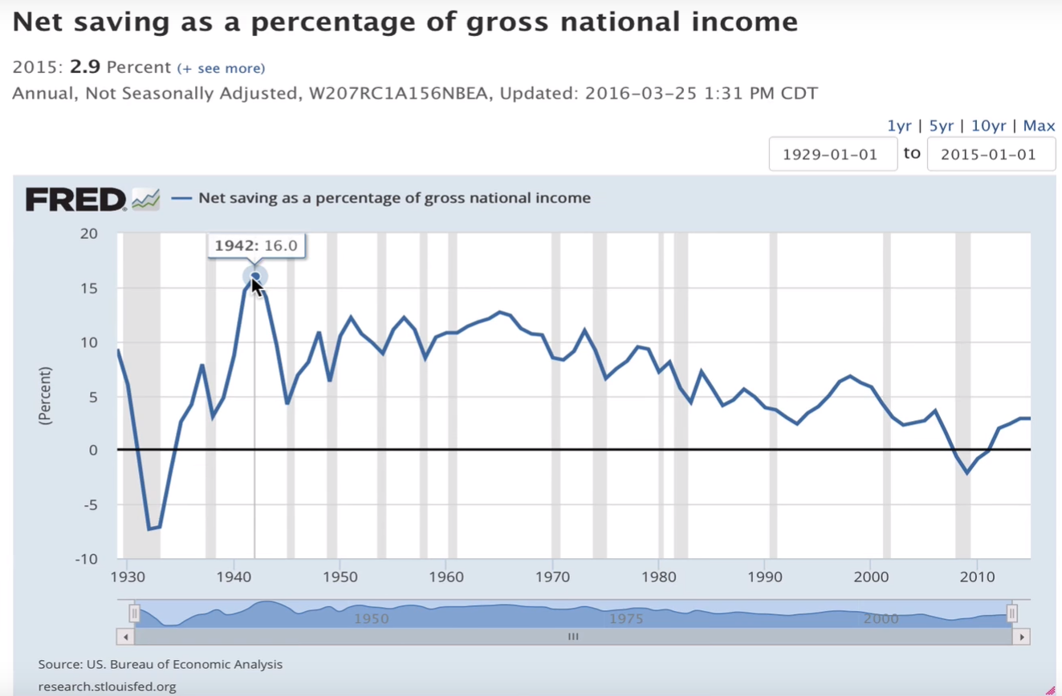

There’s likely a correlation between this Natl Savings % of Gross Natl Income and the Govt Payments to Individuals. More and more people depend on handouts from social programs to fund their lifestyle when savings rate is so low now, below 5% and likely below 2.5-3%. Last peak for Net Savings was about 1965-1966 and it has been downhill slope ever since.